6.10.2010 Smoke Watch
Tue Oct 12, 2010 11:16 am
How wrong can Forestry Tas. be?

On 6/10/2010 a 1000 hectare high intensity fuel reduction burn was lit at Mt Henry near Avoca.

It was claimed rain was expected in the Royal George area that night and the burn would be extinguished, "by late tomorrow." http://www.cleanairtas.com/videos/sctv6.10.10.avi - 19Mb download.
It is now the 18th of November and the burn is still alight.
And of course the wind has had time to change direction since it was lit, with more people affected by the smoke.
Forestry Tasmania claim they planned this burn for 12 months and watched the weather? They have no control over what they are doing. How long is it until it all goes completely wrong?

How wrong can FT be? People in Tasmania are having to suffer this smoke much longer than is publicised by them in the media.
The burn has been going continuously between the two dates.

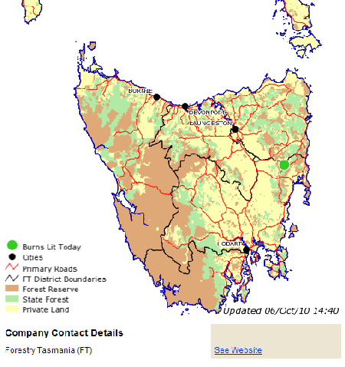
This burn was only meant to last 2 days. It was lit on the 6/10/10
currentFTburns6.10.10b...14.43.jpg (223.55 KiB) Viewed 799 times
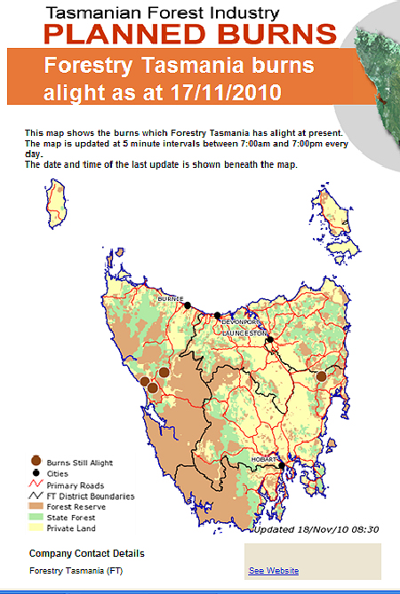
...and the burn was still going on the morning of the 18th of November 2010
currentFTburns18.11.10...08.36.jpg (331.79 KiB) Viewed 681 times

