ABC NEWS
Wood smoke linked to deaths
Posted Mon 20 Feb 2012 at 3:53pm
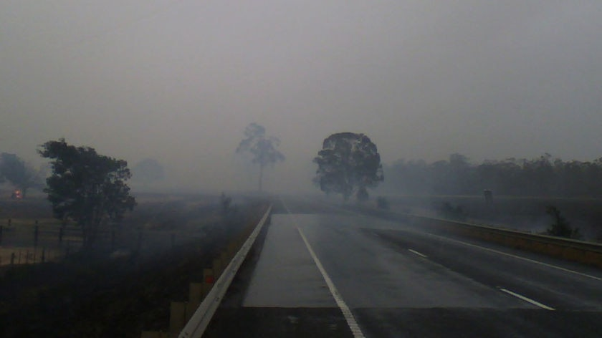
Researchers believe a study on worldwide deaths from bushfire smoke inhalation has implications for Tasmania.(Michael Brooks: ABC News)
Smoke from landscape fires has been found to contribute to 340,000 deaths worldwide each year.
Scientists from the University of Tasmania, the Menzies Research Institute as well as US and Canadian universities found smoke from forest, grass and agricultural fires affect the climate, air quality and human health.
Report co-author David Bowman says there are implications for forestry burns in Tasmania.
"We are exposing populations to risks and preventative measures have got to be taken."
"There has got to be an understanding that people who complain about the smoke have a legitimate case, the medical science is on their side now," he said.
The study found the toxic cocktails of chemicals in wood smoke is causing the most harm in very poor communities.
"Sub-saharan Africa, which is a savanna region, has a very lot of poor people doing a huge amount of burning of the savannas."
"That is also reflected in the tropical rain forests, there is a huge amount of burning, particularly in south-east Asia where there are obviously a lot of high density cities," he said.
The research is being presented today at an international climate change conference in Canada.
Last year a CSIRO study into air quality in the Huon Valley, south of Hobart, found woodheater smoke significantly outweighs emissions from forestry regeneration burns.
Cleanairtas: The EPA subsequently found forestry burn smoke outweighed wood heater smoke.
https://www.abc.net.au/news/2012-02-20/wood-smoke-linked-to-deaths/3840570

