SUBMISSION
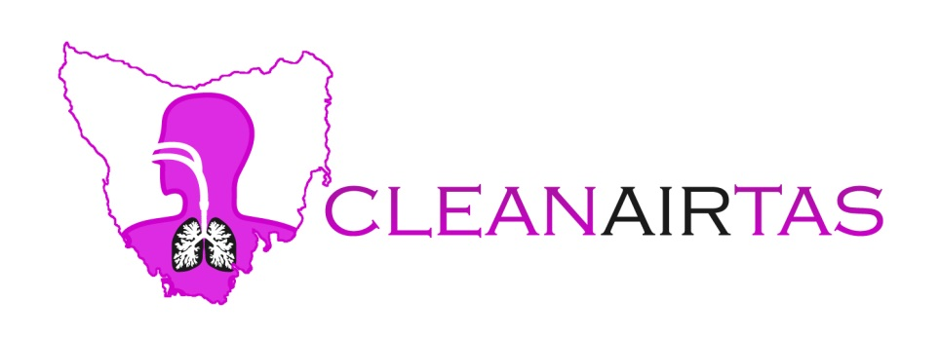

Regulatory Impact Statement
&
draft Environmental Management
And Pollution Control
(Smoke) Regulations 2017

EMPC (Smoke) Regulations Review
Environmental Policy & Support Services
EPA Tasmania
Department of Primary Industries, Parks, Water and Environment
GPO Box 1751
Hobart Tasmania 7001
EnvironmentEnquiries@environment.tas.gov.au

26th June 2017
cleanair@cleanairtas.com

EMPC (Smoke) Regulations Review
Environment Policy & Support Services
EPA Tasmania.
EnvironmentEnquiries@environment.tas.gov.au

Dear Sir/Madam,

Thank you for the opportunity to make a submission into the Regulatory Impact Statement and draft Smoke Regulations – Version 8, 5th April 2017

Parts of the Regulations are well drafted; some need changing to meet community expectations.
This submission focuses on the latter as it is generally accepted these days there are smokeless, more convenient and less costly alternatives for heating. There are also smokeless alternatives for cooking, or burning waste and these Regulations should not be seen as a “long term process” to regulate harmful smoke.

Executive Summary: - RIS Page 4
“The proposed Regulations are largely the same as the current regulations.”
The current (Distributed Atmospheric Emission) Regulations are 10 years old now and do not meet community expectations. Changes are required.
“The Subordinate Legislation Act (SLA) requires that a Regulatory Impact Statement (RIS) be prepared to assess the impacts of any proposed or substantially amended Regulations if it is assessed as imposing a significant burden, cost or disadvantage on any sector of the public.”
It is of major concern living in Tasmania under our current Regulations. Vulnerable sections of the Tasmanian population in urban, semi-rural and rural areas (the young, the elderly, those with respiratory and cardiac disease to name a few) have been disadvantaged by the Regulations in the past and therefore will continue to be in the future if the proposed Regulations, “…are largely the same as the current regulations…” by imposing a significant burden, cost and disadvantage on this section of the population.
Smoke has no boundaries, PM2.5 can travel from 100km to 1000km and little protection can be gained by staying indoors. This section of the community has little to look forward to every wood heating season with elevated levels of Particulate Matter (PM) with resulting poor health, additional medical costs and additional costs as a result of not being able to undertake the simplest of physical tasks after even one dose of deliberate wood smoke in some instances from the types of burning these Regulations are supposedly meant to regulate.
“The proposed Regulations do not deal directly with ambient air quality. Rather they provide standards and controls on particular urban sources of air pollution that are known to contribute to unsatisfactory air quality…”
However, we cannot ignore the smoke that shows up in our ambient air quality readings when wood heaters are operating. As depicted we might get a few hours of clean air a day (<5mg/m3). Someone living next to a stinking wood heater might get none.
See the graph of wood heater smoke in South Launceston below:
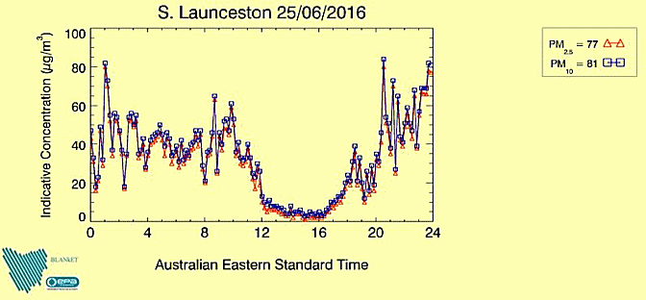
Wood heater smoke in South Launceston, Graph courtesy of EPA Air section.
Many concentrated point sources make up this smoke.

In Tasmania wood heaters are being used (continuously) for about 6 months a year and depending where you live backyard burning can occur at any time!

“Ensuring compliance will be the joint responsibility of individual councils and EPA Tasmania.”:
Experience will tell us herein lies a problem and this must be sorted out under the new (Smoke) Regulations 2017).
Clearer lines of responsibility in relation to smoke need to be worked out.
The public need to know who they should complain to, and they need to know that the Regulations will be upheld.
Examples can be cited where the EPA have said people cannot burn green waste and then a council has said yes they can.
Referring to a recent newspaper article (below) people do not know who to complain to if they are drenched in smoke. Some complain to councils and some complain to the EPA. We do not have true figures as to the total number of complaints.
The complaint figures in the following newspaper article only refer to Launceston and Hobart. What about the rest of the state? Complaint figures have not been provided by the EPA. This is significant when the EPA provides a 24 Hour1800 number for reporting air pollution complaints and councils generally do not.
http://cleanairtas.com/departments/Mercury8.6.2017-Smoke-pollution-from-wood-heaters.docx
Councils have not been proactive in the past in dealing with smoke complaints because:
- Councils generally do not have the resources to be proactive in this area.
- While they will respond to complaints, proactive implementation is a low priority.
- Councils do not see it as their role to educate the public about the regulations.•
- Council officers are likely to continue to use existing enforcement regimes under
the EMPCA (in addition to, or instead of, the regulations)
- In relation to community public relations, councils are in an invidious situation while
large scale burn-offs continue.
Some councils did not reply to the EPA survey, see below…
http://epa.tas.gov.au/Documents/DAE_Regulations_2007_Implementation_Evaluation_Report_2010.pdf

“The proposed Regulations are based on the understanding that Tasmanians place a high value on air quality and want the cleanest air possible, taking into account the State’s economic and social development goals.”

We are being told the budget is on track and Tasmania is in a better financial position than ever before. If this is correct our good economic position must surely dictate that it is time to make the necessary changes to protect our most vulnerable people from wood heater smoke and not just continue to have ‘largely more of the same’.

Whilst these Regulations do not cover other significant sources of air pollution such as planned burning by industry mentioned in 1.4 - Broad Scope of the Proposed Regulations, it must be considered that emissions from wood heating appliances or outdoor burning do have a cumulative effect on the health of susceptible groups when weather conditions allow, and this gives us harmful conditions for all groups, even supposed healthy people.

Science says wood heater emissions are more harmful than prescribed burn emissions: https://cdn.forestrytasmania.com.au/uploads/File/pdf/pdf2011/huon_valley_csiro_report_2011.pdf
This scientific report concluded that although prescribed burns had 70 times the emissions of wood heater emissions the surface concentration had 1/7 the impact of wood heaters.
The report also claimed remaining indoors provides little protection from persistent wood heater pollution.

“The RIS demonstrates that the Regulations strike a reasonable balance between the use of wood-fired heating and cooking and occasional backyard burning of ‘clean’ waste to protect human health and improve environmental amenity.”

When it comes to human health there is no such thing as, “…occasional back yard burning of ‘clean’ waste.”
To use the words ‘clean’ and ‘occasional’ should not appear in the Regulations or RIS at all as it shows a lack of understanding as to the harm wood smoke causes.

Let us substitute wood smoke for asbestos or sulphur mustard (mustard gas).
There would be an enormous outcry if mustard gas or asbestos particulates were released into the surrounding air. It is even acknowledged in the Regulations that asbestos is a prohibited substance under Outdoor Burning in the proposed draft
It would be laughable to think it would be OK if asbestos particles or mustard gas were released ‘occasionally’ or if they were described as ‘clean’.
And yet the specialized cancer agency of the World Health Organization (WHO), the International Agency for Research on Cancer (IARC), announced on the17/10/2013 that it has classified outdoor air pollution as carcinogenic to humans (Group 1 the highest) the same as these two other harmful substances.
After thoroughly reviewing the latest available scientific literature, world leading experts convened by the IARC Monographs Programme concluded that there is sufficient evidence that exposure to outdoor air pollution causes lung cancer (Group 1). They also noted a positive association with an increased risk of bladder cancer.
Particulate matter, a major component of outdoor air pollution, was evaluated separately and was also classified as carcinogenic to humans (Group 1).
It is not up for discussion, these were the WHO findings.

“Comment is especially invited on the potential costs and benefits of the proposed Regulations for business, households and other sections of the community.”
See below…

1.1 Purpose of the Document Page 5:
“The RIS has been prepared by EPA Tasmania following advice from the Department of Treasury and Finance that the proposed Regulations would have a significant effect on the community.”
It has not been made clear if the ‘significant effect on the community’ is positive or negative in this statement.
It should be realised the current Regulations are having a negative effect on the community.
Certain costs have been identified in the RIS but I am sure if Tasmania becomes more generally and widely known as a ‘designated smoking area’ then it will have significant negative effect on the community and one that Treasury and Finance needs to consider from many angles such as Health, Tourism, worker participation, children not reaching their full potential, deaths and so on.
Cleanairtas is receiving articles from Canada stating how bad our air is at times. Bad news travels fast on social media.

  - Background to the Proposed Regulations Page5:
“Managing the health impacts of wood smoke produced by domestic wood heating and backyard burning is the problem that the proposed Regulations seek to address.”
It must be remembered that Tasmania has some of the worst, if not the worst Health indicators when it comes to diseases that run parallel to poor air quality, eg non-skin cancer, asthma, COPD, heart problems, liver cancer, and so on.

  - Statement of Objectives Page6:
“EMPCA (the Act) and its subordinate legislation support the health and wellbeing of individuals, communities and the natural environment both now and into the future.”
The Regulations aim to;
- Protect the amenity and health of the Tasmanian community, particularly those living in residential areas;
- Recognise current Australian Standards for wood heater efficiency and emissions;
- Protect those adversely affected by domestic smoke emissions, and
- Protect those wishing to use wood heating and cooking, or undertake backyard burning.”
No Regulations should ever be drafted to protect those who are causing harm to others.

1.4 Broad Scope of the Proposed Regulations – Page 6:
“The proposed Regulations include provisions on heating appliances, outdoor heating and cooking, types of prohibited waste and backyard burning in urban and urban fringe areas.”
This should not only apply to urban and urban fringe areas but all areas. Everybody should be covered by the Regulations, even in rural and semi-rural areas.

‘The draft provisions on heating appliances require that all domestic-style wood heaters manufactured, imported or sold in Tasmania meet the revised Australian Standards (published 8th August 2014) for wood heater efficiency and emissions.”

The words, “…imported or sold in Tasmania…” have been significantly changed in the draft Regulations to read, “…import into Tasmania for sale…” Part2.5 (1)
The Regulations need to be changed to reflect the meaning contained in the RIS where Part2.5 (1) applies to all heaters imported into Tasmania, not just those for sale.
This will close the loophole where people can import devices supposedly for their private use that do not meet our current AS/NZS Standards.
People do not want to live next door to an imported heater that does not comply with the AS/NZS Standards whether it was imported for private use or whether it was imported for sale.

1.4 applies only to appliances sold after 8th August 2014
It does not apply to the older non-compliant heaters that have the worst efficiency and emission figures. It is stated in the RIS,”…the main objective of the new Regulations will be to limit the smoke produced by heaters….in and around urban areas.”
The main objective of the Regulations will fail if older non-compliant heaters do not form part of the Regulations.
The Regulations must contain a short-timed exit for these smoky non-compliant heaters.

It can be argued these wood heater testing Standards when being developed did not reflect real-world burning conditions but reflect optimal controlled conditions in a laboratory test that would rarely be met out in the community. Therefore, the ‘controlled’ certifying emission figures attached to a wood heater compliance plate would most likely be well under-rated when wood heater users are burning damp or green wood for example and this happens all the time witnessed by smoke belching from flues and raised ambient PM levels.

EMPCA. This part of the Act is not being complied with now. Changes need to be made to the new subordinate draft Regulations.
There must be prohibition on the sale of non-compliant heaters which applies to new heaters, 2nd hand dealers, and individuals selling old heaters, AND there must be a prohibition on the importation of non-compliant heaters and ranges for personal use. There is more about this later in the submission.
A short internet search will find the Regulations are not currently being met when it comes to the manufacture or sale of wood heaters in Tasmania, and yet the draft Regulations are claimed to have been drafted to give more of the same into the future.
We are never going to get on top of wood heater emissions if we fail to make Regulations that will be actively enforced. See examples below:
Wood heaters new and 2nd for sale in Tasmania – certified and uncertified?
https://www.gumtree.com.au/s-home-garden/tas/wood+heater/k0c18397l3008843?sort=rank

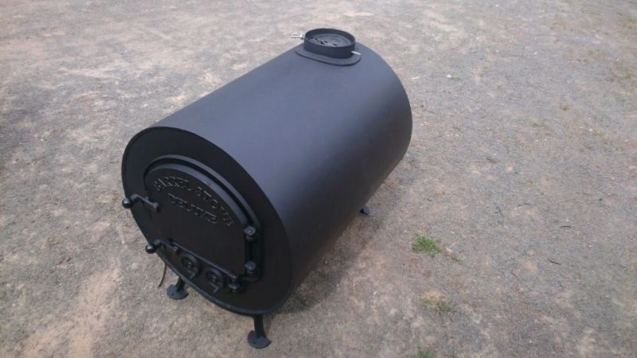

Seller's description
Date Listed:28/05/2017 Condition:New
“…now offer custom made barrel heaters designed for the man cave, outdoor area, gazebo or shed. The standard design is 570mm round and 750mm long and 4mm thick. Bottom Baffel plates ensure easy clean out and trouble free use. We can also do one off sizes with maybe a warmer plate.(add $100). (note: The door design may change from photos due to availability at the time, also the heaters are hand made and are not AU certified).”

And a 1987 installation label on a different old wood heater for sale on another website:
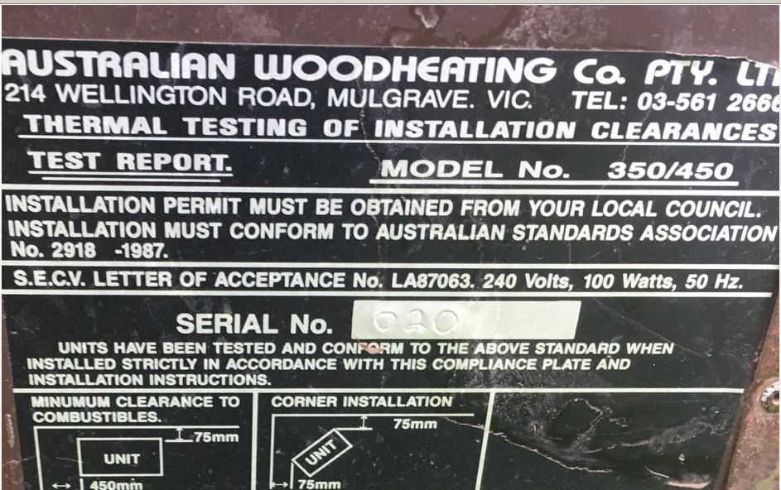

Further, we cannot just allow people to use their old wood heaters for ever that do not comply with modern standards for emission or efficiency.
These heaters need to be removed from ‘the system’.
Why should anyone be forced to live next door to a 20 year old wood heater that belches smoke far in excess of what current certification testing requires today.
Wood heaters can be made last 20 years or more when they are welded up and altered in other ways.
Those carrying out this work do not know if emissions or efficiency will be altered.

Current wood heater comments found on social media:
#10. “We make do with our 25yr old Saxon Blackwood free stander for heating and would consider nothing else, it will see us out.

#18. Mine is 25 years old, been in two houses since I have owned it , only ever replaced the door seal resprayed the outer panels, the top ones can be removed to boil water or warm up food, the baffle plate and fire box shows very little sign of flaking from rust.
I would expect it will see us and still be functional to pass on with our estate for use by a family member.

#17. I recommend Steel Fire, (a Mure’s product built about 50 years ago) a large heater of such quality that a Churchill tank looks delicate by comparison. Clean burning and efficient…

#45. There is an inventor at Bridport along with his engineering knowledge who has invented a heater that can heat his home and hot water etc.” http://tasmaniantimes.com/index.php?/weblog/article/top-5-firewood-tips/show_comments
“As part of the EPA Division’s communications to the public the requirements of the Regulations in regard to the sale of second hand heaters are periodically advertised in the major Tasmanian newspapers.” – EPA Tasmania 2/2/2015
The 2017 Smoke Regulations must apply to all installed wood heaters not just those that comply with the latest AN/NZS Standards.

AustralianCensus:
We do not have up-to-date figures on how many wood heaters or fire places are installed or operating in Tasmania, how old they are or what their emissions or efficiencies are. The EPA has been asked for questions to be included in the next Australian Census. (Submissions open in October/November this year) or to ask for funding as suggested by the ABS to have them collect the information as part of the ABS Household Survey Program prior to then.
Councils do not have a complete register of installed wood heating devices because going back it was not required and more recently it only applies to new-builds.
Council do not appear overly concerned because home insurance will mostly likely not be paid out if there is an instance and the forms have not been submitted. Owner beware!

Going back to social media the following is noted in relation to the number of wood heaters and cleanairtas has been told the number of wood heaters sales have been high in recent years:
#18. “Just about anywhere you drive around in the Huon Valley there are loads of logs in front yards that have been delivered to cut up by the owners for firewood. I also note that there is an uptake of wood heater usage around the Greater Hobart area…”

1.5 Comparison between Current and Proposed Regulations:- Page 7
Wood Heaters & Australian Standards: Page 7
AS/NZS4013:2014 flue gas emissions, 2.5g/kg 8th August 2015, 1.5g/kg 8th August 2019
Many certified wood heaters have emission factors lower than the target for 2019 (http://www.certifiedwoodheaters.com.au/)so people are asking why do we have to wait until 2019 to mandate even higher emissions than what are achievable now?
For information, non-certified or older wood heaters (similar types that are being sold 2nd hand) emit about 12g/kg and open fire places about 17g/kg.
It will still be legal for these to be used which makes a total mockery of the draft Smoke Regulations 2017.

AS/NZS4012:2014 power output and efficiency, 55% 8th August 2015, 60% 8th August 2019.
These Standards were voluntarily set by the wood heating industry itself. Although it is claimed they have wide acceptance in Australia and New Zealand it has been argued by others that the emissions factor should be greater than 60%.
If some wood heater manufacturers can exceed this 60% efficiency factor now by some degree, then it should be mandated that all manufacturers must comply with a greater efficiency factor.
Again why wait until 2019 to set efficiency figures lower that whan can be achieved now? (http://www.certifiedwoodheaters.com.au/)
EPA Tasmania needs to consider these points with the new forward projecting 1917 Smoke Regulations as both these AS/NZS standards are seemingly well out-dated already.
“Prohibit all modification of wood heaters except during repairs.”
This should read prohibit all modification to wood heaters, full stop.
Exempting modifications ‘during repairs’ will be taken that it is quite OK that modifications and tampering is acceptable. It is a well-known fact that wood heater owners are modifying wood heaters now.
To ‘modify’ means to change, reconstruct, remodel, reform, convert, revamp, vary.
It makes a farce out of the wood heater certifying practice in the first place and would require the particular heater to be re-certified to make sure that emissions have not been increased. This is the only way of knowing if smoke quantities have increased; you cannot just guess it.
Who is going to carry out these modifications? Who is going to check on alterations to every individual wood heater and who is going to pay for it?
It is not practical to police. The wording, “…except during repairs.” needs to be removed.

An exemption on, “…modifications to appliances that have been installed in and are sold together with a building…” shows this to be an extremely poorly drafted Regulation.
Modifications must not be allowed to any wood heater, old or new, sold in an existing building or in a new build. To do so would not look good for the NATA certifying authorities, or those who trust it, to have their compliance testing over-ruled so easily.

Emission of Smoke from Heaters, Fireplaces, Barbeques, etc. Page 7
The specifications for smoke plumes in residential areas would be satisfactory if complaints are acted upon by officers….at the time.
It is no good ‘after the horse has bolted’ when one serious smoke episode can affect susceptible persons for long periods and is cumulative.
Smoke plumes are not always visible from these appliances whilst there is smoke odour. Odour is the gaseous form of the compounds being burnt and this is extremely harmful if coming from a wood heater or fireplace, etc.
It is not satisfactory to have smoke odour treated separately under the general provisions of Nuisance under Section 53 of EMPCA -1994. If odour is coming from one of these wood heating appliances during its operation it needs to be covered under these new Regulations.
It is good to see clarification written into the Regulations with regards to the ‘newer ’types of emissions from fire pits, fire pots, pizza ovens, etc.

If in the RIS it states these emissions only apply to residential areas, it has to be included in the Regulations to cover all areas.

Backyard Burning: page 7 & 8.
It is acknowledged the previous 2000meters squared block burning limit was not sufficient and this has been increased in the draft Regulations to blocks of <4000 m2 for all types of burning other than what is listed as prohibited waste.
4000 square meters is 1.0 acre or 0.4 of a hectare.
Have a look at the photo below. It is on a block size of about 3 acres or 12,000 square meters!
In real terms the proposed increase in block size is going to have little effect on smoke from backyard burning. It should be noted that much of this smoke ends up in residential areas as well. This burn was in the Tamar valley at Grindelwald and the smoke from surrounding rural ended up in residential, residential aged care and the shopping village in Grindelwald and then travelled on into Launceston.

4000 square meters is insufficient and prohibition on backyard burning need to be increased to at least <12,000m3 to make any difference to deliberate smoke in our communities
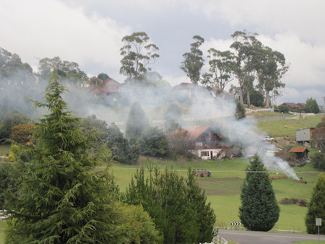

Property owners with land greater or smaller than that proposed in size do have other disposal options for green waste disposal such as mowing, mulching, or access to green waste stations.
Most people backyard burn because they are lazy or because they are allowed to. They even burn the free tip tickets that are provided to them by their council that would allow them to dispose of their green waste in a responsible manner.
Further, despite the proposed small increase in block size in the RIS there are exemptions.
Fire Permits: People are using fire as their first choice to get rid of their waste. There is nothing in the draft Regulations to prevent this.
It is too easy to get a fire permit and you do not need one if you are burning less than 1 cubic meter of specified waste. The above photo shows how much smoke can be produced from much less than one cubic meter of waste.
Fire permits are not mandatory unless there is a declared fire permit period and are encouraged mostly to prevent unnecessary call-outs by fire brigades. In the above photo what this person was doing was quite legal; legally spreading toxic smoke throughout the environment. The proposed Regulations are meant to protect us from this smoke and the draft Regulation needs to be amended.
Bylaw Permission: There are 29 councils so in reality there could be 29 different by-laws enacted to allow burning. There is nothing to stop a council enacting a by-law permission once these Regulations come into force. This would prove to make these Regulations a complete waste of time and fail to protect the health of the population.
The Regulations need to make ‘a one cap fits all’ uniform regulation in relation to by-laws.
West Tamar Council’s legal advice says a by-law cannot be made to prevent back-yard burning and smoke of this type harming people. How can a by-law be made to allow it?
If we have properly drafted Smoke Regulations the community should not have to be working under the primary provisions of our Environmental Management and Pollution Control Act, EMPCA -1994:
Environmental Nuisance:
‘Environmental nuisance’ refers to the emission of a pollutant that unreasonably interferes with, or is likely to unreasonably interfere with, a person’s enjoyment of the environment.”
A ‘nuisance’ is not what we are primarily talking about here. Yes smoke can unreasonably interfere with a person’s enjoyment of the environment but it can also cause serious harm to people’s health. This is well established.
NOTE: 'Serious Environmental Harm' involves an actual adverse effect on the health or safety of human beings.
Deliberate smoke to seriously harm someone can be, but does not have to be, high impact or on a wide scale.
This important distinction needs to be understood and taken into account in drafting these Regulations.
With regards to Backyard Burning “...an officer’s evidence of smoke emissions, based on their own senses to be admitted as prima facie evidence…”
It is useless if an officer cannot attend at the time to use their senses as prima facie evidence. This has been evident in the past. People have been let down.

Out-of-hours-smoke-pollution - : Page 15:
Brief mention is made in the RIS with regards to out of hours smoke complaints.
People have been complaining it is bad enough getting timely action during business hours.
Out of hours smoke is a problem when people are home to backyard burn, light fire pits, fire rings, barbecues, or fire up wood heaters.
“Police are authorised officers under EMPCA and Tasmania Police could potentially play a role in implementing the proposed Regulations outside normal business hours, providing a first response to complaints and investigating and enforcing provisions.
However, as nuisance smoke is not generally considered to be a public order issue, it is unlikely that the police would get involved.”
Not true.
Smoke is not just a ‘nuisance’, it is toxic and harmful.
It shares the same Group 1 carcinogen by the WHO as asbestos and mustard gas to name just two other more widely known harmful substances.
The RIS needs to specify this fact and these Regulations need to be written around this fact….not just more of the same.
In practice burners cannot be asked in any nice way to desist from burning.
Burners become aggressive, state they can do what they like on their own property and proceed to burn even more.
As people defend their right to breathe it can become a public order issue.
The Regulations have to be strong enough so that people with health problems can feel safe in their own homes and are not required to approach burners to ask them to desist, putting themselves at risk of further physical harm.
If burners cannot keep their toxic smoke on their own property then they do not burn; or they face penalties.
Provisions must be made within these Regulations to adequately cover harmful out-of-hours smoke travel.

4.1 Sumary of Costs and Benefits – Page 16

Heating Appliances (Part 2)- Costs and Benefits:
“Disposal of any remaining non-compliant heaters [Aust. Standard] (should have already been completed by the time the Regulations take effect).”
Whilst this might be true for retail businesses, the cost and benefit to the community health-wise will be minimal whilst non-compliant wood heaters and fire places are still being used and protected by these Regulations; despite the main objective to limit smoke from heaters.
As explained earlier this will take many years and the listed Benefit of “…A potential reduction in the number of smoke complaints from 2017.“ will be a long drawn out process and people will have to keep suffering.
To put it into perspective the study below relates to the latest emissions standards for wood heaters, AS4013
However, imagine what is being emitted from wood heaters produced before this latest standard…and these happen to be the ones deliberately left out of these Regulations!
There are more than initial monetary costs to retail businesses to be considered here.
http://woodsmoke.3sc.net/woodheater-car-comparison

Emission of Smoke from Heating Appliances, etc. (Part 3)–Page 17:
We are kidding ourselves.
The listed benefits of improved air quality and long term reduction in smoke related health costs will only occur if old wood heaters and fireplaces (ones that do not comply with the latest standards) are completely phased out under these Smoke Regulations. The wood heating industry would benefit from selling compliant heaters
We do not have an up-to-date number of wood heaters or fire-places in Tasmania.
There will only be a reduction in smoke complaints if people get rid of wood heaters and or move across to other cleaner forms of heating. This is because we cannot control how people use their heaters (despite our educational campaigns such as the Burn Brighter program being run in recent times) and while councils are reluctant to act on smoke complaints for the reasons previously mentioned.
A good practical example of where people have moved away from wood heating is in the newer subdivision of The Orchards in Legana. The air is virtually free of smoke each winter.
In the RIS mortality resulting from wood heating smoke has been recognised but has not been quantified in dollar terms.
“Implicit recognition that wood fired heating and cooking is acceptable if done in a responsible manner.”
Implicit recognition to choke someone, or cause their death is acceptable if it is done in a responsible manner?
These Regulations are not strong enough to be able to claim the above statement in the RIS when, “…Implicit recognition…” is not even given to susceptible people to breathe air free of wood heater smoke.

Control of Burning (Part 4) –Page 17:
As mentioned earlier in relation to backyard burning most, if not all, councils provide free tip passes that can be used to dispose of green waste in a responsible manner.
People are lazy that is why most burn their waste.
The added cost to a burner to dispose of it wisely would be negligible compared to that of making a neighbour, or should we say many neighbours, suffer.
West Tamar Council says people are only permitted to burn if there are no other alternatives.
Cost to local and state government will only decrease when provisions become uniform in these Regulations to control smoke from all sources. It is these Regulations that need to do the heavy lifting so that people, councils and the EPA do not keep going over the same thing, i.e. we do not want to keep coming back to ‘more of the same’. Regulations have not worked successfully in the past where we have 29 councils making up their own interpretations, or in fact putting their own controls on them. They have not worked where we have two bodies responsible for them, eg. EPA and local government. People need to know who they are dealing with with their smoke complaints.
Specifying what cannot be burnt, i.e. prohibited waste, still leaves a lot of waste which can be burnt that is harmful to health, ruins our amenity and costly to everybody. Under the draft Regulations people can legally burn for example uncontaminated wood or, vegetation. Smoke will be produced and people will get sick. Little has changed.
In fact it has been made easier for people with pyromaniac tendencies to backyard burn and make smoke. All they have to do is get a fire permit.

5.0 Alternatives to the Proposed Regulations – Page 19:
5.1 Rely on general provisions of primary legislation:
A case by case basis approach using the general provisions of EMPCA would result in councils having to establish and implement each and every case. This has proven to be inconsistent and unworkable for all parties.

5.2 Develop non-mandatory guidelines:
Again unworkable with so many councils and only non-mandatory. Blatant smoke offences would continue. Regulations with penalties need to be implemented.

5.3 Self-regulation.
Reducing Inspections by Regulators is not the way to go.
We have had no prosecutions in the past and I doubt we would see any in the future using this soft approach. This would be the easy way out and not what those suffering smoke inhalation expect from our regulators.
Co-regulation is no better.
Smoke producers have had years to do their bit using self-regulation. They have been able to choose to burn clean, dry waste, or clean dry fire wood and have not even been able to manage that!

6.0 Greatest Net Benefit/Least Cost.
The net public benefit of having Regulations with enforcement provisions (provided they are upheld by those deemed to be responsible) should, if drafted properly, reduce health costs to Government and reduce health costs and suffering to individuals.

Cleanairtas is privileged to know community expectations are that smoke from all sources referred to in the draft Regulations should be reduced significantly.
This can only be achieved by practical and consistent Regulations that are easy to enforce.

Appendix 2 – Detailed Explanation of Provisions – Page25:
Part 2 – Heating compliances to comply with Australian Standards
Regulation 5- Heating appliances to comply with Australian Standards
Although voluntary, the new Standards were developed through a process of consultation with regulatory authorities and the wood heating industry.
AS/NZS 4014:2014 emission limits for heaters.
AS/NZS 4013:2014 heater efficiencies.
The new Regulations will require compliance with both of the updated Standards
“The proposed prohibition on the sale of non-compliant heaters will apply to sellers of new heaters, to second hand dealers, and to individuals seeking to dispose of their old heater through private sale.”
But it does not apply to people bringing in a non-compliant heater for their own use from out of state
After all this talk about compliance with the Standards in the RIS, on Page 16 we are told a person can import a non-compliant heater or range for heating or cooking for their own use….and this does not warrant coverage in the Regulations.
Yes it does. The Regulations must apply in all situations. The Regulations must be consistent.
This inconsistency with the Regulations before they are even written seems to have been written for someone in mind. It does not even seem to be consistent with the intent of the Regulations and could possibly lead to ‘black market’ importation of heating devices into Tasmania by allowing this loophole to occur.
Further, cleanairtas members do not want to be living next door to emissions coming from a non-compliant legally imported heater or range.

Regulation 3 (Interpretation) - Page 26
“In most situations, such heaters would be used to burn firewood or other timber off-cuts in a private home.”
The heaters will be marked accordingly with the type of wood they have been tested with during their NATA certification process, eg Hardwood. This is what is permitted to burn.
“Part 2 will not apply to heaters designed and manufactured for commercial or industrial use.”
Commercial = using it in or for a business or directly/indirectly for financial gain.
There is nothing that specifies whether a wood heater or range is designed or manufactured for domestic or commercial use.
The very same heater can be used in domestic situations and in wood heating shops for example to attract business for either direct or indirect financial gain.
It is inconsistent again that, for example, a wood heating shop should be exempt from these proposed Regulations and be subject to nuisance provisions in Section 53 of EMPCA when a domestic residence that has the same appliance installed is bound by these Regulations.
The smoke emitting from each appliance will be the same and should not be fitted into ‘different boxes’.
This is not consistent/acceptable and needs to be reworked inthe Regulations.

“…existing heaters installed in Tasmanian homes (or small businesses) which do not meet the current Australian Standards will not be affected by the proposed regulations.”
Absolutely unbelievable and has been covered previously in this submission.
Under the proposed draft 2017 Smoke Regulations we can be living next to a choking heater 50 years old or one that has to comply with the new Regulations.
Again there is no consistency within these Regulations.
Now is the time when implementing these new Regulations to iron out these inconsistencies. All heaters installed in Tasmania must comply with the new AS/NZS Standards.
You cannot exempt some (especially the older smoky ones or privately imported ones) and not others. It totally goes against the intent of the Regulations to limit smoke.

Regulation 6 –Interference with heating appliance
“…prohibits a person from altering the structure, exhaust system or inlet…unless it is a temporary modification during repairs.”
This has been covered previously.
It should be noted that temporary modifications can turn into permanent modifications.
To ‘modify’ means the heater is deemed not to comply with its compliance testing Standard and should not be used.
A new certified heater or heater installation is not one that should require modifications. If so, it should be taken out of service and genuinely repaired. There are always other heating sources that can be used while these ‘temporary’ repairs are being undertaken.
The purpose of the Regulations is to minimise the effect of smoke on neighbours and to limit the general accumulation of smoke in neighbouring areas.
This will not happen if heaters have been deliberately and knowingly interfered with.
“Sub-regulation 6(3)(a) exempts modifications to appliances that have been installed in and are sold together with a building.
This is where it gets worse under these Regulations. Again there is no consistency to protect human health or the amenity from smoke.
If you buy a building you can purchase an installed, modified, old smoky old wood heater with it and this is lawful under these Regulations. It is also lawful for you to use it in that condition.
We then get to the ridiculous situation where anyone who buys a house with a wood heater installed can then proceed to make alterations to that heater. Who is to know; who is to check?
This is not acceptable under the new proposed Regulations and needs changing.
It is too conflicting with the intent of the Regulations.

Part 3 – Emission of Smoke from Heating Appliances, Fireplaces and Barbeques – Page 27
Regulation 7 Smoke emissions from appliances
Refer to previous comments
Cleanairtas agrees with the proposed limits on the duration and length of visible smoke plumes arising from these devices providing an authorised officer will attend to witness it happening not at some time later.
Councils should not put the onus onto the person being smoked out to provide evidence.

Part 4 – Control of Burning – Page 27
Regulation 8 Prohibition on burning of prohibited waste
“…unless it is otherwise lawful to do so.”
This has been dealt with earlier in this submission.
If unlawful burning does take place one would expect enforcement provisions to be used.

Regulation 9 Burning of domestic waste and green waste on land with an area of less than 4000 square meters. – Page 28

This has been dealt with earlier in this submission. The following is added:-
The purpose of the Regulations is to minimise the effect of smoke on neighbours and to limit the general accumulation of smoke in neighbouring areas.
This seems to have been forgotten in Regulation 9 with the number and types of allowed instances to burn and make smoke.
There are always other smokeless methods for waste disposal. It is just laziness in most situations where people want to burn first.
It is also worrying that Fire Service Permits are easy to obtain and, “… focus on the fire hazard aspects of green waste and may be issued without conditions relating to environmental amenity…” or people’s health.
It will be too easy for a property owner to accumulate large volumes of waste so that it becomes a fire hazard and then can be burnt.
It must be remembered that even the burning of lawful waste can create a serious smoke/health hazard.
The crux of the matter here is, “…Council officers can apply environmental conditions to any proposed backyard burning if they are approached by a landholder or resident before the burning takes place.”
It should be made unlawful for a land owner on property of this size (and the proposed increase in size) to burn, or have burnt, without first obtaining an EPN. Penalties should apply.
This Regulation needs revisiting. It is too confusing and open to abuse just to contain a “…preferred method…” or , “…any other approved mechanisms…” under 9(1)(b) written in.
The summary for green waste disposal options on properties less than 4000m2 on page 29 in the RIS allows too many options for burning/making smoke.
There is no mandated process to follow in the draft Regulations and people will just choose a Fire Permit as their first option rather than the best option for the continued protection and enhancement of environmental amenity and human health.
Safer and more suitable procedures for lawful waste disposal on land of this size need to be formulated otherwise we are destined for more of the same where inconsiderate people just go ahead and burn and communities are made to bear the cost.
Currently, Regulation 9 is more about being allowed to burn than smoke abatement.

Waste Disposal on Properties greater than 4000m2 – Page 30
If the same Regulations for properties >4000m2 apply to properties < 4000m2 then green waste burning on the smaller properties need to be revisited and sorted out. They will be unworkable and cause a lot of people deliberate harm in more densely populated areas.
Previously councils were meant to be looking after green waste disposal on properties less than the old figure of<2000m2 and the EPA looking after properties greater than the old figure.
It is not clear who deals with what now under Smoke Regulations 2017.
This needs clarification.

Part 5 Miscellaneous & Schedule 1
Regulation 11 Prescribed offences and Environmental Infringement Notice Penalties – Page 30
It would appear that penalty provisions were available previously but were not used.
This has to change. Education is not always appropriate.
Regulation 7(1) is missing from Schedule 1 and this is a serious omission. It needs to be included and must be greater than ‘not exceeding 10 penalty units’. The penalty units need to be set high enough to deter people from allowing their appliances to smoke and to make it cost effective for officers to investigate. Out of hours investigation are time consuming and expensive.
Continuous smoke from an appliance is one of the worst events as it prevents you going outside or opening up the house for clean air, or hanging washing out. It gets into your house and you can breathe it for months on end with no escape. Sanitizing costs to remove smoke particulates in the house are extremely expensive and so is shifting house. There is no escape until the point source is stopped!
Fine not exceeding 50 penalty units. Penality 2 penalty units.

General statement of costs and benefits – Page 36
“The main benefit to the community from producing new and updated Regulations is the continued protection and enhancement of environmental amenity and human health.”
Cleanairtas has highlighted where there are costs and problems with the ‘same approach’ as before.
Members of the public do not want to have to put themselves or their families at physical risk by having to approach burners to ask them to desist. This comes at a personal cost.
Members of the public should not be made suffer and have their lives shortened by deliberate smoke when we have new Smoke Regulations 2017 being drafted that will be in force for many years.
There are more to costs than just monetary costs.
One would assume that the benefits of lower emissions from compliant wood heaters coming into the community would be flowing through by now but we are still getting high levels of ambient air quality as a result of wood heating and smoke complaints are still coming in, even if people do not know who to complain to.
This makes it all the more important to remove all the older non-compliant wood heaters that would be contributing more than their fair share of emissions to our smoke levels.
The costs would be reaped many times over in better health outcomes, inside and outside the home.

Appendix 4:
EMPC (Smoke) Regulations 2017:
Detailed comments on the RIS have indicated where changes need to be made to the proposed Regulations and are to be read in conjunction with the following:

Part 1 – Preliminary:
Residential premises:
(b) the block of land on which the building, …is incomplete.

Part 2(5)(1) - Heating Appliances to Comply with Australian Standards:
“A person must not manufacture, import into Tasmania for sale, or sell, a heating appliance to any other person unless –
- the heating appliance is marked in accordance with AS/NZS 4013:2014 and
AS/NZS 4012:2014, and
- a laboratory certificate is in force in relation to heating appliances of the same model as that heating appliance.
Penalty: Fine not exceeding 50 penalty units.”
SHOULD BE CHANGED TO READ…refer to RIS submission:
Part2(5)(1) - Heating Appliances to Comply with Australian Standards:
A person must not manufacture, import into Tasmania for sale or for private use, gift, use or sell a heating appliance to any other person unless –
- the heating appliance is marked in accordance with AS/NZS 4013:2014 and
AS/NZS 4012:2014, and
- a laboratory certificate is in force in relation to heating appliances of the same model as that heating appliance.
Penalty: Fine not exceeding 50 penalty units.

Part 2(5)(3) – “If requested to do so by the Director, a person must produce to the Director, for inspection by the Director, a laboratory certificate that is in force in relation to heating appliances of the same model as any heating appliances the person is manufacturing, importing into Tasmania for sale or selling.
Penalty: Fine not exceeding 50 penalty units.”
SHOULD BE CHANGED TO READ…refer to RIS submission:
Part 2(5)(3) - If requested to do so by the Director, a person must produce to the Director, for inspection by the Director, a laboratory certificate that is in force in relation to heating appliances of the same model as any heating appliances the person is manufacturing, importing into Tasmania for sale or selling or for their private use.
Penalty: Fine not exceeding 50 penalty units.

Part 2(6)(3) – “Subregulation (1) does not apply in relation to -
- a person temporarily modifying a heater appliance during the course of making repairs to the heating appliance;”
Part 2(6)(3)(a) SHOULD BE REMOVED….Refer to the RIS submission.

Part 2(6)(3) – “Subregulation (1) does not apply in relation to -
- a heating appliance that has been installed in, and is sold together with, a building.”
Part 2(6)(3)(b) SHOULD BE REMOVED….Refer to RIS submission.
Part 3 (7) – Emission of smoke from heating appliances, outdoor heating or cooking appliances and fireplaces.
Part(3)(7)(1) “A person is not to cause, or allow, a heating appliance, an outdoor heating or cooking appliance or fireplace to emit smoke that –“
SHOULD BE CHANGED TO READ…refer to RIS submission:
Part(3)(7)(1) A person is not to cause, or allow, a heating appliance, an outdoor heating or cooking appliance or fireplace to emit smoke or odour from the solid fuel heating source that -

Part(3)(7)(1)(a) “is visible for a continuous period of 10 minutes or more; and”
SHOULD BE CHANGED TO READ…refer to RIS submission:
Part(3)(7)(1)(a) is visible or the solid fuel odour can be smelt for a continuous period of 10 minutes or more; and

Part(3)(7)(1)(b) “during that continuous 10 minute period, is visible for a continuous period of 30 seconds or more –“
SHOULD BE CHANGED TO READ…refer to RIS submission:
Part(3)(7)(1)(b) during that continuous 10 minute period, is visible or the solid fuel odour can be smelt for a continuous period of 30 seconds or more -

Part(3)(7)(1)(b)(ii) – “in the case of a heating appliance or an outdoor heating or cooking appliance that is not in a building, or part of a building at a distance of 10 meters or more from the point where the smoke is emitted; or”
SHOULD BE CHANGED TO READ…refer to RIS submission:
Part(3)(7)(1)(b)(ii) – in the case of a heating appliance or an outdoor heating or cooking appliance that is not in a building, or part of a building at a distance of 10 meters or more from the point where the smoke or solid fuel odour is emitted; or

Part(3)(7)(1) – Fine not exceeding 10 penalty units.
SHOULD BE CHANGED TO READ…refer to RIS submission:
Part(3)(7)(1) – Fine not exceeding 50 penalty units.

Part(3)(7)(2) – “If, in a proceeding for an offence against subregulation (1), an authorised officer or a council officer gives evidence, based on the officer’s own senses, that smoke was emitted from a building, or land occupied by the defendant, that evidence is prima facie evidence of the matters so stated.”
SHOULD BE CHANGED TO READ…refer to RIS submission:
Part(3)(7)(2) – If, in a proceeding for an offence against subregulation (1), an authorised officer or a council officer gives evidence, based on the officer’s own senses, that smoke or solid fuel odour was emitted from a building, or land occupied by the defendant, that evidence is prima facie evidence of the matters so stated.

Part 4(9) Burning of domestic waste and green waste on land with an area of <4000m2
Part 4(9(1) “A person must not burn domestic waste or green waste in the open, or in an incinerator, on land that has an area of less than 4000 square meters, unless the burning of the domestic waste or green waste is –“
SHOULD BE CHANGED TO READ…refer to RIS submission:
Part 4(9(1) A person must not burn, or have burnt, domestic waste or green waste in the open, or in an incinerator, on land that has an area of less than 4000 square meters, unless the burning of the domestic waste or green waste is -

Part 4(9(1) EXTRA CLAUSE(c) TO BE ADDED…
Part 4(9)(c) Taking into account Part 4(10)(2)(a)(i)(ii)(iii)and(iv) and, Part 4(10)(b)(i) and (ii)

Part 4(9)(2) Any burning of domestic waste or green waste in the open, or in an incinerator, on land that has an area of less than 4000 square meters must not be otherwise unlawful.
REMOVE the WORD ‘not’ to read…
Part 4(9)(2) Any burning of domestic waste or green waste in the open, or in an incinerator, on land that has an area of less than 4000 square meters must be otherwise unlawful.

Part 5 Miscellaneous
Part 5 Schedule 1 Environmental Infringement Notice Penalties
Regulation 7(1) is missing from Schedule 1.
SHOULD BE INSERTED TO READ…refer to RIS submission:
Schedule 1 Column 1: Regulation 7(1) [Amended].
Schedule 1 Column 2: Penalty units 2

Thank you.

Yours faithfully,

Clive M. Stott for Cleanairtas

