Forestry Minister: Corporations Behind Forest Fires

http://www.en.netralnews.com/news/currentnews/read/8235/forestry.minister.corporations.behind.forest.fires
Sunday, 16 July 2017 | 23:15 WIB

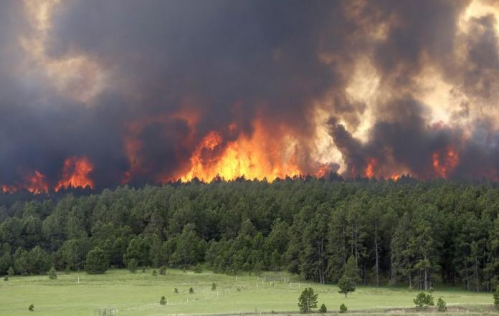
Forestry Minister: Corporations Behind Forest Fires
JAKARTA, NETRALNEWS.COM – The Ministry of Environment and Forestry says it continues striving to enforce the law for perpetrators of environmental crimes. One of them is the perpetrator of forest fire at the location of Jatim Jaya Perkasa (JPP) plantation, in which the company was recently deemed guilty by the court.
"Investigators from the Ministry of Environment and Forestry do not hesitate to crack down on the perpetrators of environment and Forestry crimes, and the constitutional rights of people to get a good and healthy environment," said Siti Nurbaya Bakar, Minister of Environment and Forestry through the ministry’s twitter, @KementerianLHK, on Sunday (7/16).
To be known, the court has declared JPP guilty for violating Law Number 32 Year 2009 Article 99 paragraph 1 on Environmental Protection and Management. The District Court of Justice (PN) of Rokan Hilir Riau Province decided JPP guilty and had to pay IDR1 billion.
In addition, the Ministry of Environment and Forestry filed a civil suit related to land fires at the palm plantation of JPP area of 1000 ha. The Jakarta High Court also granted the Ministry appeal with JPP who had to pay a loss and land recovery amounting to IDR491 billion. KLHK assess, this court decision proves that there are corporations that are behind forest fires and land.
Siti Nurbaya and the Ministry also hope the perpetrators of environmental crimes can be deterrent and can not do any violation of the law again. In addition, KLHK also states that it will prioritize the crime of corporate LHKs to be responsible for the destruction and pollution of the environment in its activities.

ReporterMartina Rosa Dwi Lestari
Editor (ENG) Turkhan Mustafa Akhyar
Editor (INA)Lince Eppang

