A small group of people they say?
“Residents urged to take precautions as smoke from Canadian wildfires impacts local air quality
Press-Republican
However, for some pollutants there may be a moderate health concern for a very small number of people who are usually sensitive to air pollution.”
https://www.pressrepublican.com/news/residents-urged-to-take-precautions-as-smoke-from-canadian-wildfires-impacts-local-air-quality/article_3d30f2f8-5c04-11ef-98b1-b74eb04b9c7b.html

A small group? Looks like a pretty big group to me.
You don’t need to have a prior heat attack to be vulnerable. It can cause a heart attack in anyone because smoke thickens your blood.
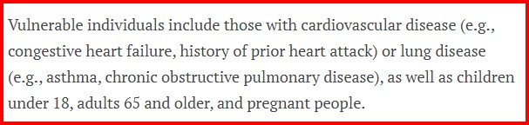

No. The studies have been done. We don’t need to suffer while more studies are done. Of course, many academics will always say more studies need to be done!
Ask them why they want to do more studies. If the smoke stops the studies stop.

The IARC (the cancer arm of the WHO) determined harm back on the 17th Oct. 2013
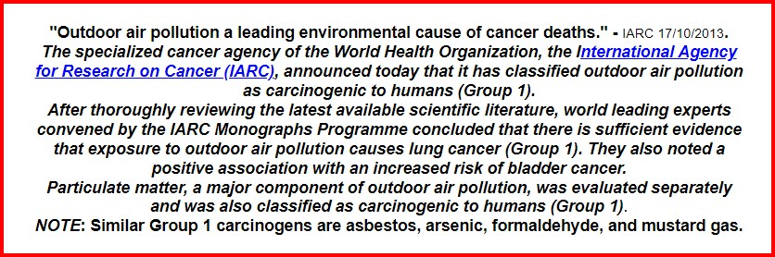

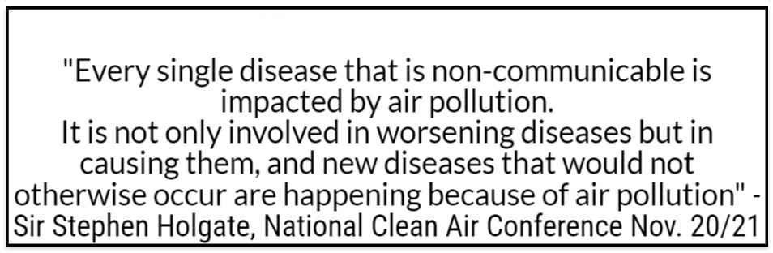

We must use rapid attack to put these fires out when they start.
We need to treat pyromania, it is a disease.
We must stop minimising the health effect of air pollution.
We must stop trying to divide who it effects.
We must use the Precautionary Principle when it comes to fire and smoke
We must stop burning stuff.

