This is how most bushfires in Australia start, and how we know
https://www.abc.net.au/news/science/2019-11-20/bushfire-ignition-source-how-we-know/11701132

ABC Science

By environment reporter Nick Kilvert
Updated 20 November 2019 at 3:08 pm
First posted 20 November 2019 at 9:32 am

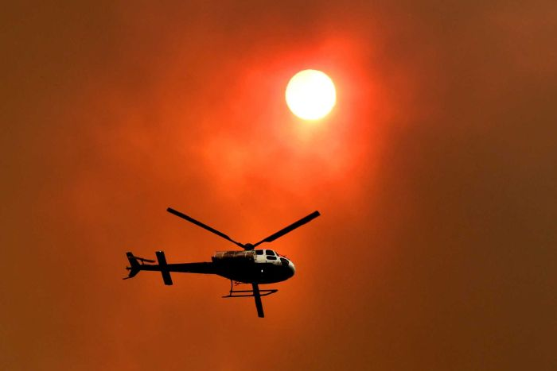

Lightning is a common ignition source, but the majority of fires are linked to people.
(AAP: Dan Peled)

As fires continue to burn in different parts of Australia, investigators work to provide answers on the exact causes of devastating blazes.
Last week we learnt that the Binna Burra fire, which destroyed the historic Binna Burra Lodge in South East Queensland, was started by a carelessly discarded cigarette.
And the Gold Coast hinterland bushfires the week before may have been started by army live-firing exercises at the Kokoda Barracks, a spokesperson for the Australian Defence Force has conceded.
We know that hot, dry and windy weather increases the risk of fires starting, but here's what we know about what actually provides the spark.

The nine categories of bushfire ignition

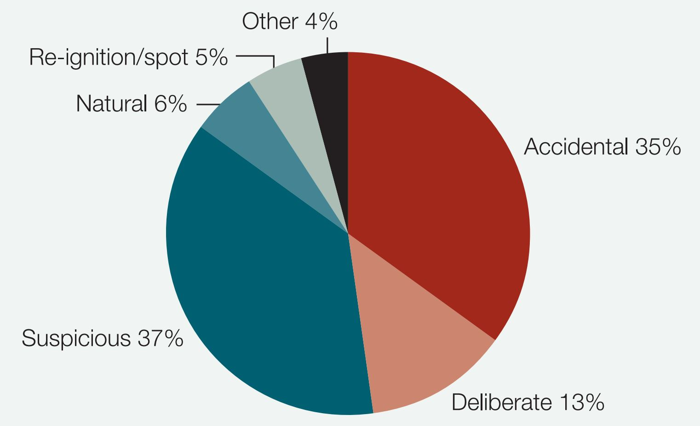

The majority of bushfires are started either intentionally or unintentionally by people.
(Supplied: Australian Institute of Criminology)

Fire investigators have nine categories for the ignition sources of fires:
Smoking: Smoking isn't as common a source of bushfire ignition as we might think. There have to be some really specific conditions for a flicked cigarette to spark a fire — temperatures generally need to be above 27 degrees Celsius, and humidity below 22 per cent. And the cigarette needs to land in a loose fuel bed, and at a quite specific angle, according to Richard Woods, who runs Wildfire Investigations and Analysis consultancy.
Fires that start by the roadside are more likely to be ignited by burning pieces of carbon ejected from car exhausts than a cigarette butt, said Mr Woods, who is also an adjunct lecturer in wildfire investigations at Charles Sturt University.
However, he warned that we're currently facing weather conditions in which a cigarette could cause a fire, and we need to take every precaution we can to avoid providing a spark.
Police have said that two local teenagers have been questioned about the fire that destroyed the Binna Burra Lodge, and that a discarded cigarette was likely the cause.
Burning off/debris: Burning off is a regular source of bushfire ignition.
Two men were charged with ignoring a fire ban and "setting fire to the property of another person", after the Carwoola fire in southern New South Wales which destroyed eight homes, numerous vehicles and livestock in 2017.
Arson: The motivations for why people commit arson are varied and complex, but arson is behind a large number of bushfires both in Australia and internationally.
While figures vary, around half of all bushfires in Australia are either known to be deliberately lit or are considered suspicious, according to the Australian Institute of Criminology.
Police are treating several blazes around New South Wales as suspicious.
Railway cause: Railway has its own category, as trains are a surprisingly common source of bushfires. Brake failure in trains can throw out a wall of sparks, sometimes igniting dry vegetation along the side of the tracks and across significant distances.
Burning carbon embers thrown from train engine exhausts can also start bushfires.
Campfires: Embers from campfires, and campfires that aren't properly extinguished are a bushfire hazard. Many popular campsites have moved away from open campfires, and provide fire rings to contain embers.
Equipment use: Chainsaws, angle grinders, mowers, etc. Using grinders or welding equipment outdoors is not permitted during a fire ban because of the sparks they throw.
According to Sunshine Coast police, several fires started on the Sunshine Coast in September from sparks thrown by lawn mowers.
Children: Children are also categorised separately, as they are often implicated in starting fires, but usually they're considered to be out of curiosity rather than malice.
Several fires in the New South Wales 2013 bushfire season were tracked to children. And police have charged a juvenile with starting a Central Queensland bushfire which destroyed 14 homes this week.
Lightning: It's the most common ignition source in remote areas, but not all lighting is equally likely to start a fire, according to Mr Woods.
"Positively charged lightning is far more likely to start a fire," he said.
"Positive charges only make up about 10 per cent of lightning strikes."
Lightning sparked the 2015 Esperance fires which killed four people, and lightning strikes are believed to be the source of some of the fires that have recently hit Queensland and New South Wales, according to Mr Woods.
"In the recent fires of northern New South Wales and Queensland, it was reported that there was a big lightning band that went through the area."
Miscellaneous: Power lines, firearms, blasting, glass refraction, electric fences, and more.
If army exercises turn out to be the culprit in the Gold Coast fire last week, it won't be the first time, according to Mr Woods.
"There's a case in New South Wales which occurred in 2013 that was known as the State Mine fire," he said.
"What happened there was that they were doing controlled explosion of ordnance that caused a fire that then escaped."
Electric fences and power lines are also common sources of ignition, but glass refraction — where sunlight is concentrated through a discarded glass bottle — is so rare it's almost a myth, Mr Woods said.

How do we know how fires start?

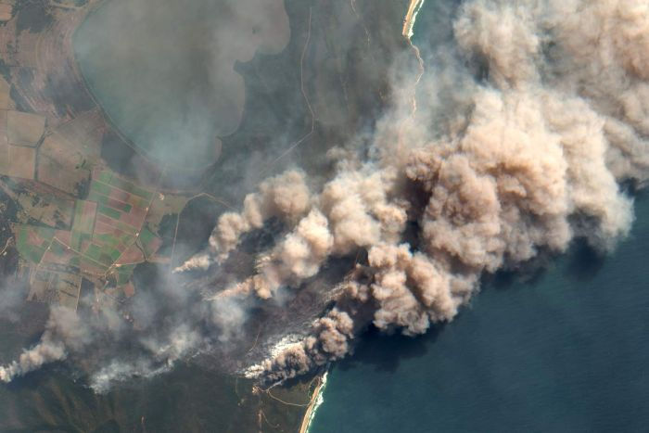

Investigators look for a number of signs to trace the origin of a fire.
(Getty Images: Orbital Horizon)

To find the point where a fire started, investigators look for the area where the fire burned the "coolest".
At that point, the fire is just getting started and doesn't do as much damage to things like logs and tree trunks, compared to a roaring fire front.
"We read what we call fire indicators — the interaction of fire on combustible and non-combustible materials," Mr Woods said.
"We essentially track the fire back to where the coolest part of the fire is located."
They can also read signs to gauge the direction the fire was travelling in.
That includes things like '"foliage freeze", where the burnt leaves tend to be frozen in the direction the fire was moving.
The side of logs exposed to fire will also burn more deeply than the lee side of the log.
And grass stems are burnt deeper on the side of the fire's approach.
Investigators also consult with locals and aircraft pilots, and can get information from dashcam footage as well.
Once the site of the ignition is located, they look for obvious clues like cigarette butts, which will often survive a burn, as well as match heads, or pieces of catalytic converter from car exhausts.
Sparking or fallen power lines or electric fences can be an obvious sign, and there is typically at least one eviscerated tree at the site of a lightning strike.
"In a lightning-strike ignition you can have shards of branches, charred timber and a tree nearby, that's quite clearly got a fracture on it arising from lightning," Mr Woods said.
There are also a number of signs left by arsonists.
Obvious ones are footprints and discarded petrol tins, matches or lighters, but there are other signs investigators look for that Mr Woods can't elaborate on.
"There are a number of techniques that we can use to identify the ignition source," he said.

