Roger Jaensch MP
Liberal Member for Braddon
Minister for Education, Children and Youth
Minister for Environment and Climate Change
Minister for Aboriginal Affairs
Minister for Parks
minister.jaensch@dpac.tas.gov.au

Dear Sir,

I am sure you would be aware I am a past Vice President of Burnie Young Liberals and worked in state health, but nothing can be more important than breathing clean air.

Your areas of Environment, Climate Change, Aboriginal Affairs and Parks, all have something to do when it comes to the science that says there is no safe level of air pollution.

If I heard Michael Mansell correctly on the ABC this morning, today you were meeting with an aboriginal group to work out land transfers?
What concerns us is the handing over of land for one group of people to run it how they like which could be to the detriment of all people.
I am talking smoking ceremonies and cultural burning.
Unfortunately, it is a known fact our Aboriginal people die younger than others. and this can be attributed in many cases to diseases. Smoke related diseases.

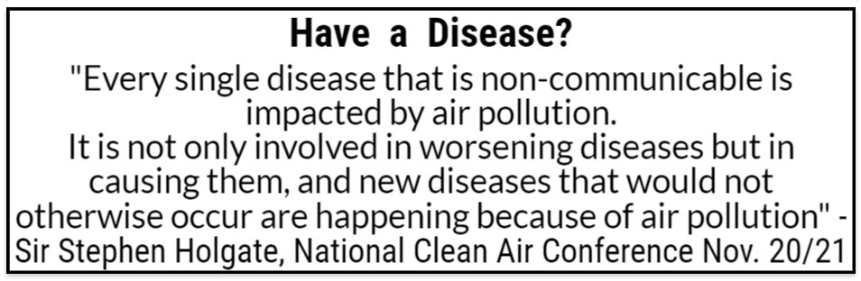

You would be aware of funding problems in health in Tasmania and how we have almost always the worst outcome in every health category in Australia.

PM2.5 is the major component of wood smoke.
The specialized cancer agency of the World Health Organization, the International Agency for Research on Cancer (IARC), announced on the 17/10/2013 particulate matter was a Group 1 carcinogen which is the most harmful Group. Air pollution was also determined to be a Group 1 carcinogen.
Other similar Group 1 carcinogens are asbestos, arsenic, formaldehyde, and mustard gas and we know how harmful these are.

Exploring Australia's east coast in 1770, Captain James Cook described the land as “a continent of smoke” and noted that “we saw smoke by day or fires by night wherever we came.”
For many years now Health science tells us we cannot go back to this.

Further, one other portfolio of yours is Children.
According to the science children are affected more by particulate matter than adults because their respiration rates are higher.

People, all people, need to stop burning stuff.

Yours faithfully,

Clive Stott
cleanair@cleanairtas.com
1st December 2022

