**Raw PM2.5 OUTDOOR AMBIENT AIR QUALITY in ug/m3**

**The WHO says: “Particulate pollution has health impacts even at very low concentrations – indeed no threshold has been identified below which no damage to health is observed.”**

<https://www.who.int/news-room/fact-sheets/detail/ambient-(outdoor)-air-quality-and-health>

**There is no safe level of fine particulate pollution.\***

**Particulate matter is harmful to everybody even to so-called healthy people.**

**So why are we using these graded PM2.5 health-based categories extending way beyond good air quality?**

**Many different categories exist around the world but none echo the science. It is more confusing when some jurisdictions report in overly-complicated Air Quality Indexes (AQIs).**



**The above categories come from EPA Vic. Australia.**

**Health Tasmania has set the GOOD category at 0-9 ug/m3** but it is still not good enough.

**5ug/m3 is considered very good ambient air.**

**We have shown in the past we can achieve this when people stop burning stuff!**

**It is time we all caught up with the science and adopted**

**BINARY HEATH-BASED CATEGORIES and comments using**

**1 hour rolling average metering and 10 minute real-time reporting for raw PM2.5 data. Just two categories: Green is very clean air. Red is unhealthy for everyone.**

**Any episode above 5ug/m3 must be classed as an exceedance.**

**There should be no exemptions, e.g. planned burning, solid fuel heating.**

**Smoke is smoke as far as our health is concerned.**



**l l > >**

**0 5ug/m3**

**5ug/m3 is considered to be very clean ambient air.**

**(Particle mass, or weight in ug/m3’ will no doubt continue to be used until ‘**[**particle counts and nano particulates**](https://www.nature.com/articles/s12276-020-0405-1)**’ are further recognised in health studies).**

**\*At present 5ug/m3 should be considered a Practical Threshold for AAQ**

**However, there is no safe level of Particulate Matter.**

Contd….

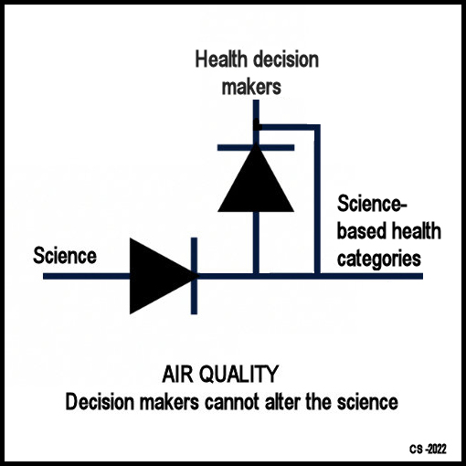

PM2.5 Health-based categories V.5.1 – C. Stott 3.7.2022