**[Article](https://tasmaniantimes.com/category/article/)**

**The Black Dust on the Spirits …**

By [**Torren McMaster**](https://tasmaniantimes.com/guest-author/torren_mcmaster)

Posted on October 3, 2018

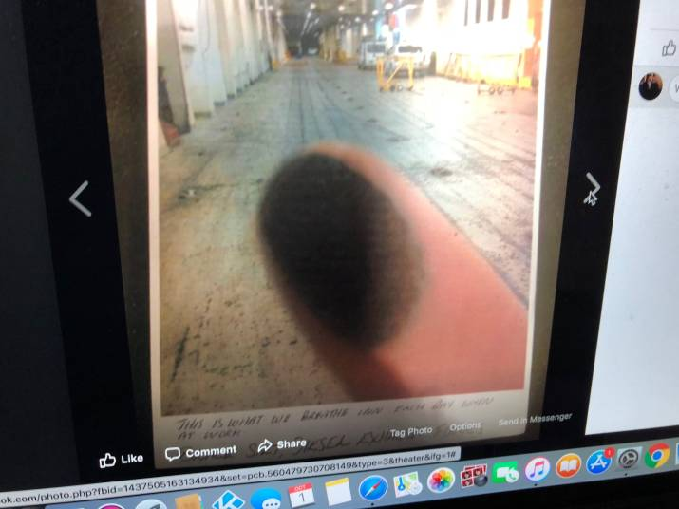

“These are just a few of the many photos I captured whilst working onboard the Spirit of Tasmania.

Do you think any of the politicians or other authorities I have contacted would work with this black dust floating around in their office.

That ship is our office and employees are faced with these putrid conditions every day.

The fact that this monumental issue is being ignored to the detriment of the workers, is an absolute disgrace by all involved.”

**Go here:** [*https://tasmaniantimes.com/2018/10/the-black-dust-on-the-spirits*/](https://tasmaniantimes.com/2018/10/the-black-dust-on-the-spirits/) to read this article and the comments published on Tasmanian Times.

*Spirit of Tasmania I* and *Spirit of Tasmania II* are the vehicular/passenger ferries that run between Devonport in Tasmania and Melbourne in Victoria.

Note: TT-Line owns these two vessels.

TT-Line is a government business enterprise wholly owned by the Tasmania government.

contd….

Tue 23/10/2018 10:42 AM

From: EPA Tasmania.

To: cleanair@cleanairtas.com

“The EPA does not undertake ambient atmospheric monitoring for sulphur dioxide or oxides of nitrogen at the Devonport port.

The EPA is not responsible for the monitoring of on-board air quality (as opposed to ambient air quality) of ships berthed at or visiting Tasmanian ports. For details of the environmental management practices of the Spirit of Tasmania I and the Spirit of Tasmania ll you may wish to contact the TT-Line Company Pty Ltd (TT-Line).”

**From:** Ruth Bannon [<mailto:rmb@spiritoftasmania.com.au>]

**Sent:** Tuesday, 11 December 2018 10:24 AM

**To:** [cleanair@cleanairtas.com](mailto:cleanair@cleanairtas.com)

**Subject:** Spirit of Tasmania - Email via website

Dear Clive

Last month, we received the below enquiry.

Please accept our apology for the late reply.

**From:** "[cleanair@cleanairtas.com](mailto:cleanair@cleanairtas.com)" <[no-reply@wufoo.com](mailto:no-reply@wufoo.com)>

**Sent:** Thursday, November 15, 2018 4:35 PM

**To:** [contactus@spiritoftasmania.com.au](mailto:contactus@spiritoftasmania.com.au)

**Subject:** Email via website

|  |  |
| --- | --- |
| **Name \*** | Clive Stott |
| **Contact number \*** |  |
| **Email \*** | [cleanair@cleanairtas.com](mailto:cleanair@cleanairtas.com) |
| **State/Territory \*** | TAS |
| **Enquiry type \*** | Vessel Facilities Enquiry |
| **Your message \*** | Good afternoon Spirit of Tasmania,  Belinda Adams Exec. Officer for the Minister for Health Michael Ferguson DPAC has referred me to you for answers.  Can you please advise if there is an air monitoring program undertaken on-board the two Tasmanian vessels Spirit of Tasmania I and Spirit of Tasmania II and if so, when did it commence, who does it and how often?  Thank you. |

TT-Line does complete periodic air monitoring on board Spirit of Tasmania I & II via an independent third party. TT-Line vessels remain compliant with all applicable legislation and marine convention requirements.

Kind regards

|  |  |
| --- | --- |
| **Ruth Bannon**  Customer Contact Centre Manager[Spirit of Tasmania](https://www.spiritoftasmania.com.au/) |  |
| **T:** +61 3 6419 9011  **M:** +61 417 391 779  **F:** +61 1800 636 110  **E:** [rmb@spiritoftasmania.com.au](mailto:rmb@spiritoftasmania.com.au)  **W:** [spiritoftasmania.com.au](http://www.spiritoftasmania.com.au/) | Spirit of Tasmania  Esplanade (PO Box 168E)  East Devonport TAS 7310 |

Tues 11/12/2018 11:30 PM & 20/01/2019

From**:** [cleanair@cleanairtas.com](mailto:cleanair@cleanairtas.com)

To**:** [rmb@spiritoftasmania.com.au](mailto:rmb@spiritoftasmania.com.au)

Dear Ruth,

Thank you for your email.

With respect your reply is very brief and does not entirely answer my questions.

***When did the air monitoring program commence on-board these vessels?***

***Who does the air monitoring?*** You say an independent third party. Who is this independent third party? Name?

***How often?*** You say periodic. How often is periodic?

Further, you now raise the point that, "TT-Line vessels remain compliant with all applicable legislation and marine convention requirements."

Can you please be specific? What is the applicable legislation and marine convention requirements you refer to?

Thank you.

Kind regards,

Clive S.