Sydney Morning Herald
August 16 2017 - 12:15AM
http://www.smh.com.au/environment/no-warning-calls-for-earlier-pollution-alerts-after-smoke-cloaks-sydney-again-20170815-gxwh6r.html

'No warning': Calls for earlier pollution alerts after smoke cloaks Sydney again

Peter Hannam
A second day of heavy pollution levels over Sydney caused by controlled fires in the Blue Mountains has prompted calls for earlier warnings and a review of the costs and benefits of hazard-reduction burns.
Over the past two decades, the average annual loss of homes in fires in the Sydney region has been cut to about 20 compared with 25 "if we didn't do anything" in terms of hazard reduction, said Ross Bradstock, director of the Centre for Environmental Risk Management of Bushfires at the University of Wollongong.

More NSW News Videos
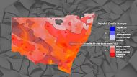
Video duration
02:04

Is NSW a major bushfire risk this summer?
Researchers estimate three hectares of bushland need to be burnt on average per year to reduce the area scorched by a wildfire by a hectare. The cost is about $50 million a year, Professor Bradstock said.
For Louise Steer, an asthmatic since childhood, the lack of broadcast alerts meant she wasn't aware of the heavy smog until she looked out her window in Stanmore on Monday morning.

Related Articles
- 'Critical levels': Sydney bushfire warning for September
- Return of 'big dry' points to active, early fire season
"There was no warning – there never are any warnings – and it really annoys me," Ms Steer, a lawyer, said. "People really need to be told to take their medication and stay indoors if at all possible."
The Rural Fire Service blamed weaker-than-expected winds on Monday for a build-up of smoke that was still bringing very poor to hazardous air quality for parts of Sydney into Tuesday afternoon. (See NSW air quality index chart below.)
Owen Price, a University of Wollongong researcher, said the latest event was not as severe as the big haze in May 2016, which one study found led to as many as 14 "avoidable deaths" in Sydney.
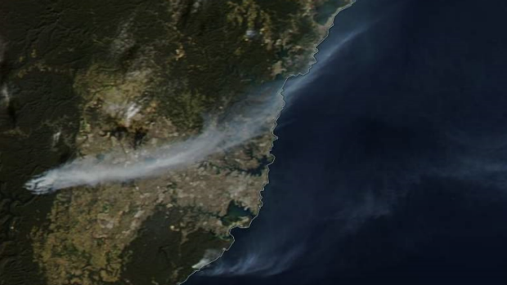Satellite image shows the smoke from fires streaming across the Sydney Basin from fires near Warragamba Dam. Photo: NASA
The debate over the benefits and costs of hazard-reduction burning is likely to intensify if, as expected, climate change narrows the window authorities can light fires with minimal risk that they will get out of control.
This spring may be a case in point after a damp autumn limited such burns earlier in the year and a dry, warm end to winter is rapidly reducing the opportunity to catch up.
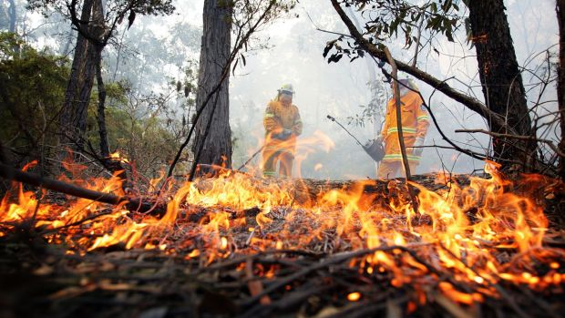A prescribed burn operation in Wedderburn, Sydney's south-west in 2015. Photo: Jeff Darmanin
Rob Rogers, deputy commissioner of the Rural Fire Service, said authorities had posted alerts about planned burns, including a 3000-hectare area near Warragamba Dam that delivered much of the smoke over Sydney.
The public should also expect such fires during periods of fine, mostly calm weather at this time of year.
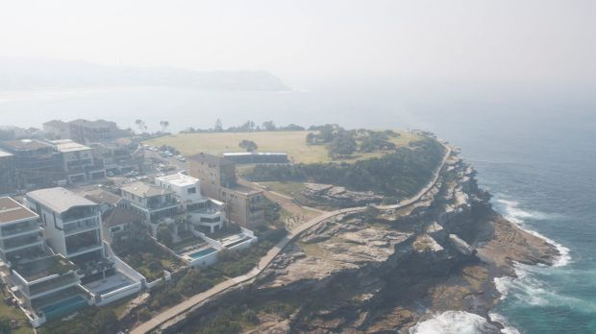Sydney was cloaked in smoke on Monday, with the poor quality air extending into Tuesday. Photo: Brook Mitchell
"People can't be passively awaiting the government to tell them everything they need to do," Mr Rogers said.
Beyond saving homes, hazard-reduction burning is also credited with removing fuel from known fire paths and limiting the erosion from hillsides that often follows major blazes. Erosion can undermine infrastructure such as roads but also affect water quality in reservoirs - such as Warragamba.
Facebook comments on the RFS warnings, though, were mixed.
Posters such as Cheryl Gatt, said the dry undergrowth and lack of rain "all adds up to a potential bad bushfire season".
"If you live in bushfire-prone areas like we do then you appreciate the firies doing these reductions," she said.
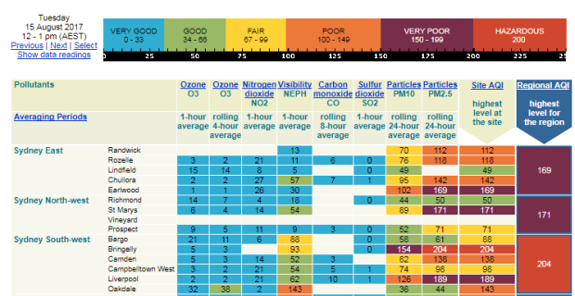
Others, such as Margaret Spinak, shared some of Ms Steer's concerns.
"I would like to see the results of some studies showing that these burns are actually effective in protecting properties," Ms Spinak said. "Studies that weigh up the positives of hazard reduction burns with the negative impacts on people's health and the adding of extra carbon into the atmosphere which in turn fuels bushfires when they happen."
Improved modelling could help reduce air quality effects while maintaining burn results, said Melissa Hart, a researcher at the University of NSW-based ARC Centre of Excellence for Climate System Science.
"We've been looking to try to improve the planning of bushfire times to reduce the risks to the community while still allowing the vital work to be carried out," Dr Hart said.
Dr Owen, who has reviewed a paper by Dr Hart due for publication soon, said it may be possible delaying burning for a couple of hours could lead to less smoke build-up in the Sydney basin.
Simon Louis, a meteorologist at the Bureau of Meteorology, said this week's smoke event showed how timing might have made a difference.
During winter, heat inversions are common as cool air seeps into the basin from the mountains. It then settles under a stable warmer air mass allowing pollution to accumulate, Mr Louis said.
As we saw this week, the smoke itself can then reinforce the inversion by limiting the penetration of the sun's rays.
"With the smoke around, it can act like clouds and slow down the mixing through the stable level," he said.
For its part, NSW Health said it works closely with agencies, such as the Environmental Protection Authority, Office of Environment and Heritage and the RFS, in initiating public alerts when potential health risks arise.
OEH "provides alerts to the public through its air quality website and SMS alert system," a NSW Health spokes person said.
Ms Steer said many people were not social media, particularly the elderly who may be most affected by heavy pollution. She recommended broadcast news bulletins add warnings such as in their weather forecasts.

Related Articles
- Hazy days of winter as Sydney wakes up to a smoky sunrise

