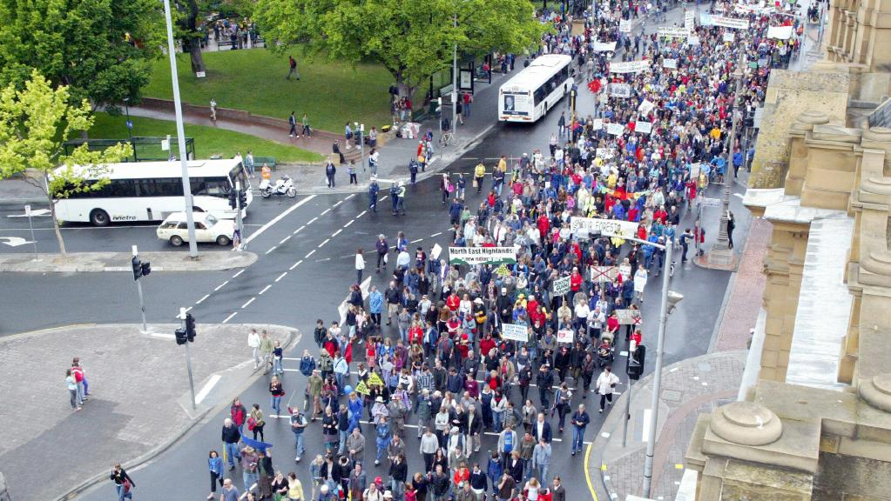
Opinion

It’s been 10 years since the painful demise of one of Tasmania’s most contentious industrial projects
Peter Henning, Mercury
November 13, 2017 1:30am
ABOUT this time a decade ago, Gunns thought it was at the top of its game, at the peak of its power and influence.
During 2007 it had shown it had control over the two major political parties in Tasmania and that it was able to exert that power by having favourable legislation enacted in their interest to build the Tamar Valley pulp mill.
In effect, Gunns controlled both houses of parliament in 2007, and was the dominant force in Tasmania’s business establishment. It was the shaping voice in the alphabet soup of players in the so-called timber industry, more realistically the woodchip industry, from Forestry Tasmania to unions.
Gunns had escaped the overview of the state planning and assessment authority for major projects, the Resource Planning and Development Commission, early in the year, soon after RPDC chairman Christopher Wright found it “critically non-compliant” in meeting guidelines for building the mill.
After Gunns withdrew from the RPDC process, Premier Paul Lennon called a special session of parliament to fast track the assessment, passing the now notorious Pulp Mill Assessment Act. This enabled the government to appoint Finnish company Sweco Pic to undertake the assessment, designed to fit Gunns’ specified timeline. Sweco Pic built pulp and paper mills, making it an ideal choice for a benefits-only assessment, and it dutifully completed the task within two months.
Soon after the assessment was made public, independent Australian engineering consultant, Professor Andrew Wadsley, shredded it as an abrogation of responsibility to the impact of emissions on health, society and the environment, and “not fit for purpose”.
Tasmanian politicians could not care less. Their focus was on serving Gunns, so they passed the permit legislation with minimum fuss, again with the support of both major parties at state and federal level. Malcolm Turnbull, federal environment minister, did his best to impose the most minimal of federal conditions.
Gunns had already told the media it expected to begin work at the mill site before the end of the year, and that there were no issues about obtaining finance, expected to be in the vicinity of $1.7 billion.
So, with Gunns at the acme of its economic power and political influence, what could possibly go wrong?
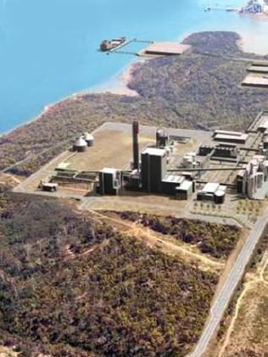An artist's impression of the proposed mill.
The supreme irony was that every major decision Gunns made was met with increased community opposition, especially in the Tamar Valley, but elsewhere as well, including interstate.
A major blunder was its decision in late 2006 to launch a SLAPP suit against a diverse range of critics — the Gunns 20 — just before announcing its intention to build the mill in the Tamar Valley.
Litigation against ordinary people, including a doctor, a pensioner and a filmmaker, among Greens, ENGOs and others, was guaranteed to harden opposition, not stifle it. Gunns chose to defy the power of the “underdog principle” and to play the card of intimidation. It backfired.
Similarly, the decisions to locate the mill in the Tamar Valley, to abandon the chlorine-free model it initially proposed, to use native forest feedstock, to pump effluent into Bass Strait and pollutants into the Launceston-area airshed, and to demand a water resource exceeding all other residential and industrial use in the northern region, were guaranteed to galvanise community opposition.
Moreover, the passage of the PMAA and the permit legislation generated a new dimension of opposition.
Questions of democratic governance, due process, political transparency and accountability, unjust law and use of statute to undermine common law, became prominent issues.
In particular, there was a backlash against section 11 of the PMAA, which prohibited recourse to legal action “in respect of any action, decision, process, matter or thing arising out of or relating to any assessment or approval of the project under the Act”.
This was taken to mean, by people living in the Tamar Valley “sacrifice zone”, that parliament had deliberately excluded them and their interests as citizens from political representation.
To challenge section 11, even by class action — in the event the mill in operation did adversely affect people’s health or livelihood — would be both risky and expensive, especially in the absence of baseline studies, which the government had not done.
In June, about 15,000 people participated in a protest march through Launceston, and in November about 10,000 marched in Hobart. In October, TAP member Karl Stevens, a first-time candidate for the West Tamar Council, romped in, as did several anti-mill candidates for the Launceston City Council.
Gunns and Labor-Liberal politicians misread the nature of this opposition to the mill, seeing it as effete and NIMBY and therefore ephemeral on the one hand, or as extreme greenies, even terrorists — as one union official claimed — on the other.
Labor-Liberal politicians had lost connection with representative democracy, and perceived their role in purely partisan placement terms, as careerists. This was demonstrated in spades at the end of 2006 when Bob McMahon invited Professor Eduardo Jaramillo, the lead scientist appointed by the Chilean government to investigate the disastrous impact of the Valdivian mill on local communities and the environment, to visit Tasmania.
Jaramillo expected to meet with government officials and politicians, but was shunned by the government and all members of the opposition except one.
The nature of the Tasmanian political system in its raw essentials, as representative of corporate power rather than the public interest, was exposed for all to see in 2007. The fact that in 2017 Tasmanian politicians continue to lament Gunns’ failure indicates that nothing has changed.
The defeat of the pulp mill project was a victory for grassroots democracy against the corporatised bipartisan political establishment, against the odds, a victory for the possibility of food-based agriculture rather than plantations, but was that victory an aberration?
If so, that is not the fault of those brave people who stalled, at least for a time, the quest, as Wilson Tuckey hoped, to turn Tasmania’s productive land and native forests into a vast plantation wasteland for pulp.
Peter Henning is a Tasmanian historian and author based near Launceston.
Comments
Post Comment

