Herald Sun

Creditors put in the frame as liquidators pursue Gunns millions
NICK CLARK, Mercury
July 1, 2016 12:00am
THE liquidator of Gunns Ltd is heading to court to claw back tens of millions of dollars it says was unfairly paid to creditors in the months before the timber company went into liquidation in 2012.
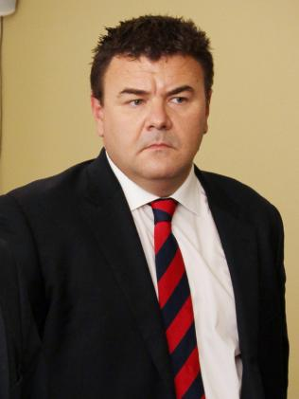PPB Advisory liquidator Craig Crosbie.
PPB Advisory liquidator Craig Crosbie had already recovered $2.6 million from 17 creditors, says an annual report to creditors lodged with the Australian Securities and Investments Commission.
“Legal proceedings have been commenced against approximately 70 creditors who received significant payments during the period from March 30, 2012 (when the Gunns group became insolvent) and September 25, 2012 (when the group was placed in voluntary administration),” the report said.
“We have investigated about 1000 payments which the Gunns group made to more than 200 creditors prior to the winding up and considered whether any payments might be void and recoverable as an unfair preference.”
MORE: LIQUIDATORS SEEK COURT QUIZ OVER GUNNS DEBT
Creditors include Tasmanian and Victorian logging businesses allegedly paid after Gunns became insolvent.
Sources told the Mercury that liquidators are seeking more than $50 million from creditors in amounts varying from $300,000 to $5 million.
When Gunns was placed in receivership in 2012 it owed more than $436 million to secured creditors, $6.6 million to 543 staff and $823 million to 1038 unsecured creditors.
A directions hearing was heard in the Supreme Court of Victoria in April.
“Given the early stage of various proceedings we are not yet able to confirm the amount and timing of any return to unsecured creditors,” Mr Crosbie’s report said.
Secured creditors were likely to take a haircut on their debt.
“It is unlikely there will be sufficient proceeds from secured asset realisations to satisfy secured creditors’ debt,” Mr Crosbie said.
Liquidators did not expect any money to be available for distribution to unsecured creditors from realisation of assets.
“However, there may be future distributions to unsecured creditors from potential recoveries relating to voidable transactions,” he said.
Receivers Korda Mentha have been trying for more than two years to sell the Bell Bay pulp mill site and associated permits that cost Gunns more than $220 million to obtain.
Last year the liquidators summonsed Gunns’ auditors KPMG to produce books and financial records.
Originally published as Creditors put in the frame

