http://www.examiner.com.au/story/5193131/quick-responses-from-firefighters-kept-fire-damage-to-a-minimum/?cs=12
- Home
- News
- Latest News
January 27 2018 - 6:00PM

Quick responses from firefighters kept fire damage to a minimum

Kasey Wilkins
Latest News
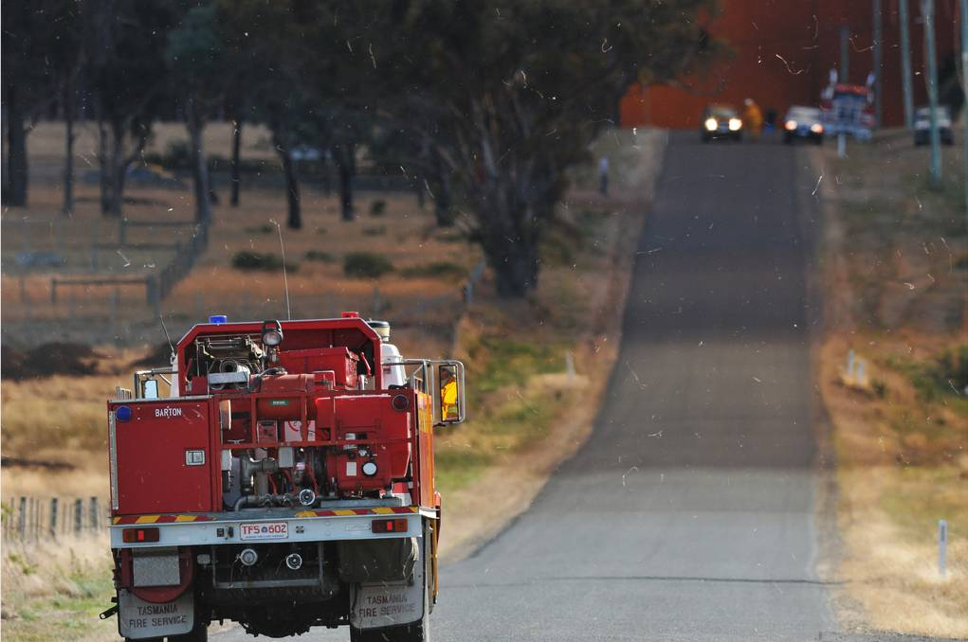
Tasmania Fire Service had a busy day on January 27, as crews worked to quickly contain and extinguish several fire outbreaks.
Station Officer Andrew Emery said high temperatures and “extremely dry” vegetation meant that fire crews were not taking any chances heading into Very-High Fire Danger and warm weather across the state on January 28.
“Our whole intent today with the predicted conditions was to respond to any fires rapidly with heavy resources to keep them small, enabling us to limit the damage and fully extinguish the fires quickly,” he said.
Crews responded to fires in the North and North-West of the state at Zeehan, Smithton, and Latrobe, with a fire at Sassafras burning through six hectares of pine plantation and natural bush.
A 17.5 hectare fire at Blessington was contained, with the fire being patrolled by firefighters over the coming days.
A fire at Swansea was brought under control on Australia Day with the assistance of specialist remote area firefighters working with volunteer crews to extinguish the blaze.
“Three of the fires over the last 24-hours have started from re-ignitions of old fires which landowners previously believed were extinguished,” Mr Emery said.
“TFS urges any landowner who has previously had fires burning on their property to check them again to make sure that they are, indeed, fully extinguished.”
A Total Fire Ban will be in effect in the South of the state from midnight on January 27 through to midnight on January 28.
TFS urge the public to be vigilant and report any fires by calling Triple-Zero (000).
For more information visit www.fire.tas.gov.au. Listen to ABC Local Radio in the event of an emergency.
RELATED STORIES:
- Scrub fire at Long Hill road, Sassafras
- Tasmania Fire Service working hard to contain blazes across the state
- Tasmania Fire Service crews called to Blessington blaze

