July 23 2019 - 6:00AM
Letters to the editor | July 23, 2019
OPINION
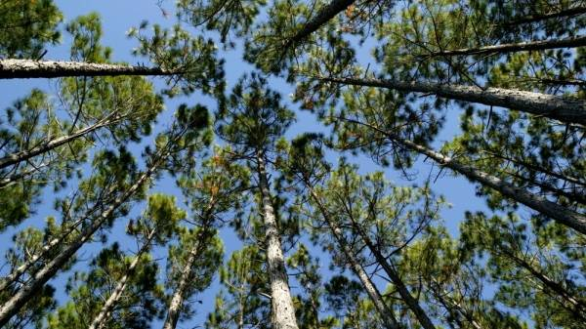
Plantations
A RECENT TV campaign tells us wood is sustainable and shows a nursery with millions of pine and gum seedlings.
It starts off by showing our beautiful natural forests as they are now, but you only have to turn to Oregon and Arizona in the US to see how these converted same height, same age plantations contribute to catastrophic wildfires by changing wind patterns.
California's worst fires are because of climate change and beetle infestations.
So, we want to go down the path of the US do we, where we will see more deliberate fires, more pesticides and herbicides being used?
More people losing everything, including their lives, and our fire, forestry and parks being funded many times over our health budget to try and put these uncontrollable fires out?
Even today Tasmania lets its bushfires burn because we can't put them out.
Smoke as a result of deliberately converted plantations is not sustainable.
Don't just tell us half the story.
Clive Stott, Grindelwald.

