RAAF - Indigenous members smoking.

From: cleanair@cleanairtas.com

To: <raaf.brandmanager@defence.gov.au>

Date: Wed 14/06/2023 02:54

RAAF

Dear Sir/Madam,

I have just been looking through your web pages and came across the following photographs/articles.

The RAAF prides itself on its members keeping fit and in good health, then I see the following…

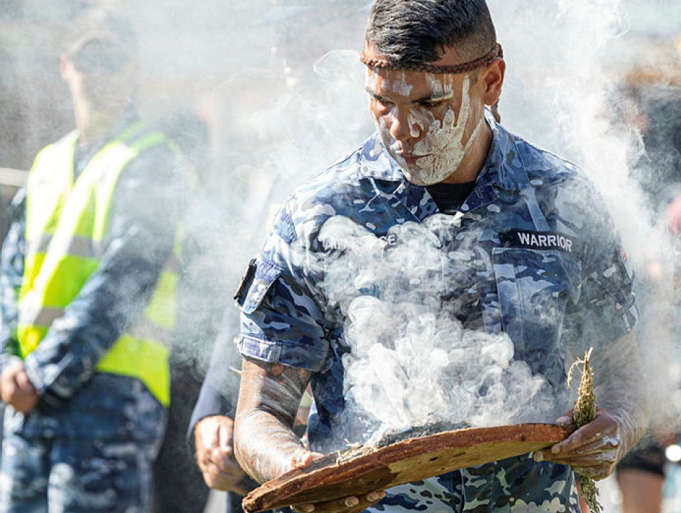

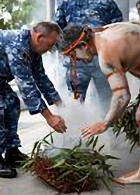

This concerns me because the World Health organisation says there is no safe level of air pollution.

The WHO have even deemed air pollution and PM2.5s to be Group 1 carcinogens, the highest level of all carcinogens..

PM2.5s are known to enter the lungs, cross over into the blood stream, and carry their toxins to every organ in the body.

Then we have this:

“Every single disease that is non-communicable is impacted by air pollution.

It is not only involved in worsening diseases but in causing them, and new diseases that would not otherwise occur are happening because of air pollution” – Sir Stephen Holgate, National Clean Air Conference Nov. 20/21

Medical science tells us that indigenous people die 10 years younger than the rest of us, and this is mostly because of smoke related diseases.

This is sad when we know the harm wood smoke causes and yet these people are deliberately inhaling this stuff.

Is it time for a rethink, for their sake?

Look forward to hearing your views.

Yours faithfully,

Clive M. Stott